1) Not Null constraint

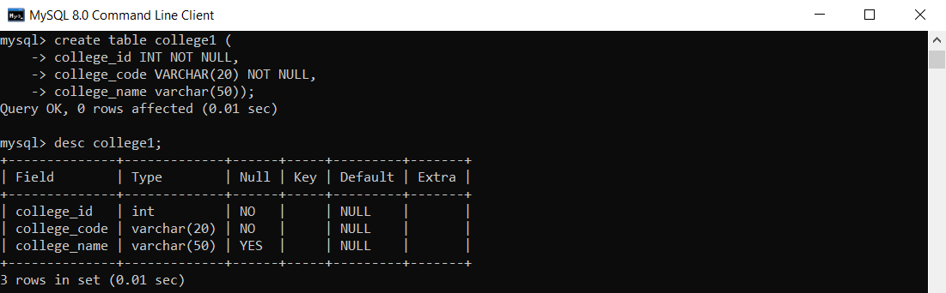

2) Unique Constraint

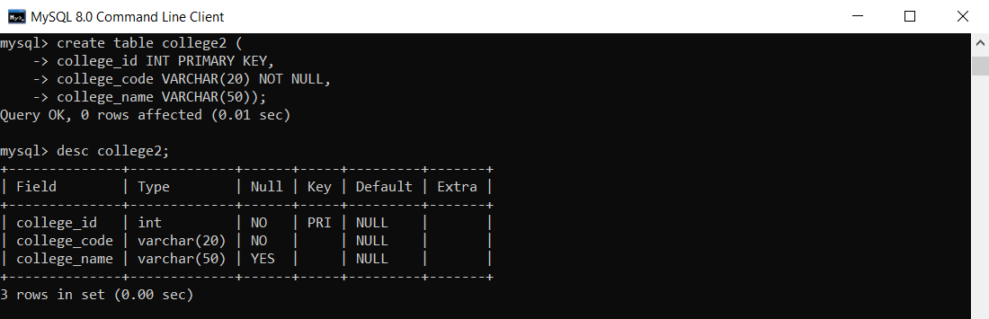

3) FOREIGN KEY Constraint

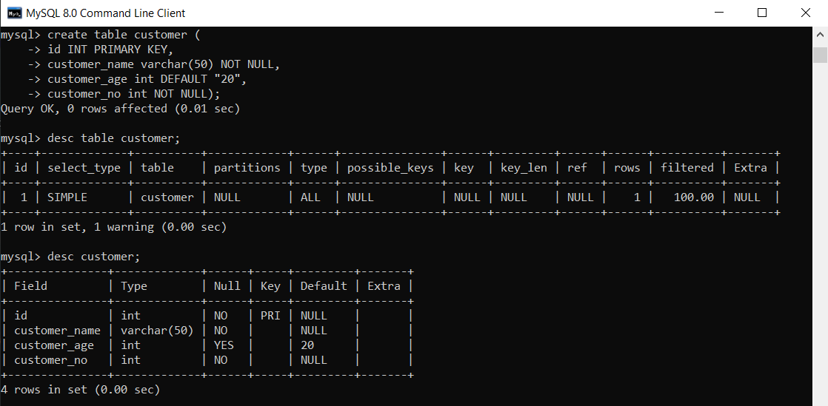

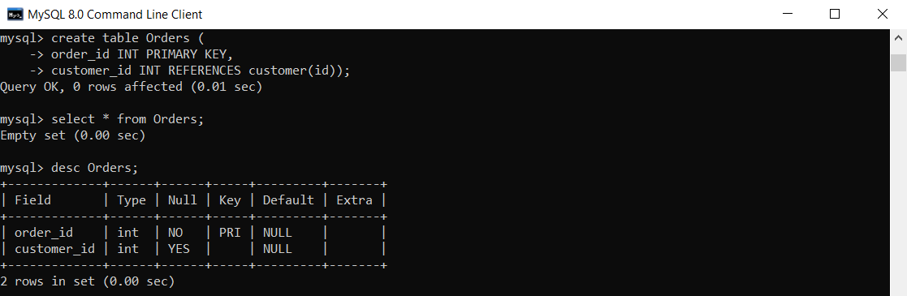

4) CHECK Constraint 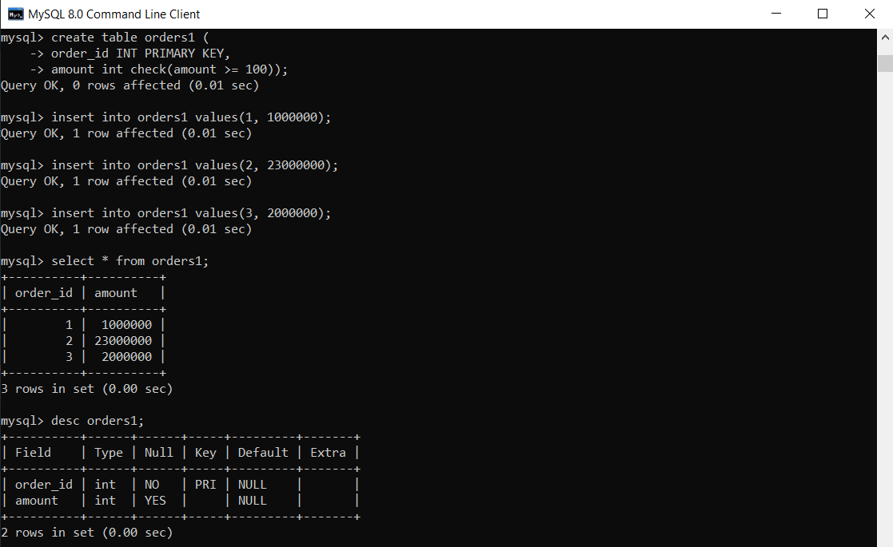

5) DEFAULT Constraint

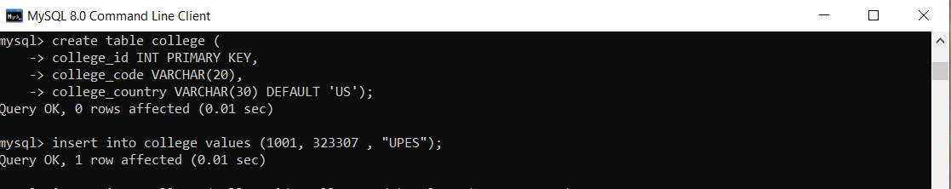

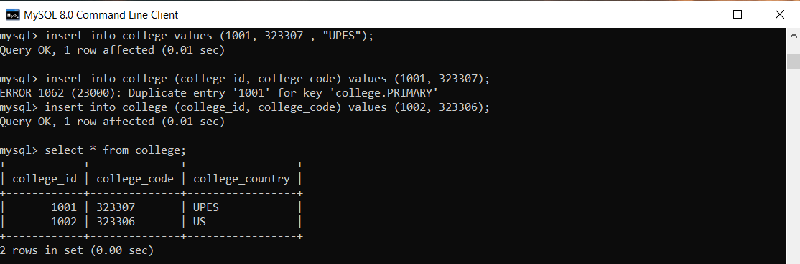

6) CREATE INDEX Constraint

